Lab 1.1 — Snowflake Intelligence & Cortex AI Foundations

Table of contents
Lab 1.1 — Snowflake Intelligence & Cortex AI Foundations 1
Table of contents 2
Introduction 3
Learning Objectives 3
Prerequisites 3
Part 1 — Environment Setup and Access Control 4
Step 1 — Initialize Sandbox Database 4
Step 2 — Grant Cortex Permissions 4
Part 2 — Seeding the Enterprise Data 6
Step 1 — Create and Populate the Table 6
Part 3 — Extracting Insights with Cortex 8
Step 1 — Basic Sentiment Summarization 8
Part 4 — Prompt Engineering for Natural Language Query (NLQ) 10
Step 1 — The Text-to-SQL Prompt 10
Knowledge Check 13
Troubleshooting 13
Symptom: Error: "Unknown function SNOWFLAKE.CORTEX.COMPLETE" or "Insufficient privileges" 13
Symptom: The generated SQL in Part 4 includes ```sql markdown backticks. 13
Conclusion 13

Introduction
The evolution of Business Intelligence is shifting rapidly from static, predefined dashboards to interactive, conversational interfaces. To build these "Talking Dashboards," BI Developers must shift compute and AI inference as close to the data as possible.
In this lab, you will bypass external API integrations and utilize Snowflake Cortex—a fully managed suite of Large Language Models (LLMs) hosted directly within your Snowflake environment. You will engineer prompts to analyze enterprise event data, summarize user feedback, and translate Natural Language Queries (NLQ) into executable SQL, laying the groundwork for the custom UI applications we will build later in this course.

Learning Objectives
Upon completing this lab, you will be able to:
- Initialize a Snowflake AI sandbox and configure necessary Cortex role permissions.
- Execute foundational LLM functions natively against relational data using SQL.
- Engineer context-aware prompts to instruct the LLM on output formatting (e.g., generating raw SQL vs. conversational summaries).
- Dynamically generate SQL queries from natural language questions using a given database schema.

Prerequisites
Before starting, ensure you have:
- Access to a provisioned/paid Snowflake account (Cortex features are restricted or disabled on standard free trials).
- Access to the Snowsight Web UI.
- Appropriate privileges to create a database, create a schema, and grant the CORTEX_USER database role.

Part 1 — Environment Setup and Access Control
Before we can leverage AI models natively, we must create a dedicated sandbox and ensure your role has the correct privileges to invoke Snowflake Cortex functions.

Step 1 — Initialize Sandbox Database
Execute the following SQL commands in your Snowsight worksheet to create the foundational environment.
CREATE DATABASE enterprise_ai_sandbox;
CREATE SCHEMA enterprise_ai_sandbox.analytics;
USE DATABASE enterprise_ai_sandbox;
USE SCHEMA analytics;
USE WAREHOUSE compute_wh;

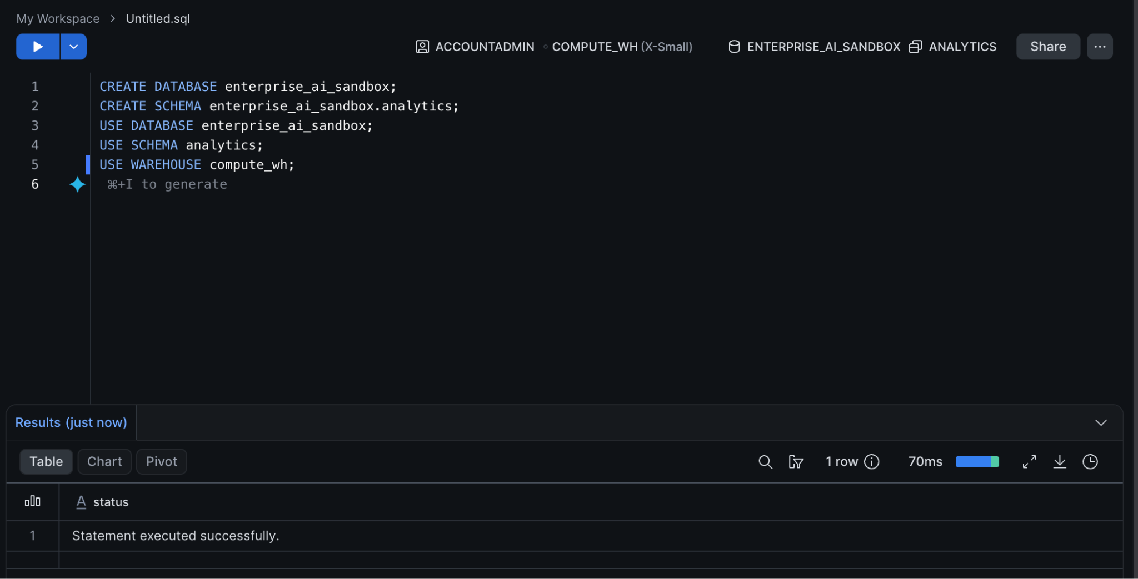

Step 2 — Grant Cortex Permissions
To use LLMs, your active role must be granted the Cortex User database role. Execute this command, replacing SYSADMIN if you are using a different custom operational role.

GRANT DATABASE ROLE SNOWFLAKE.CORTEX_USER TO ROLE SYSADMIN;

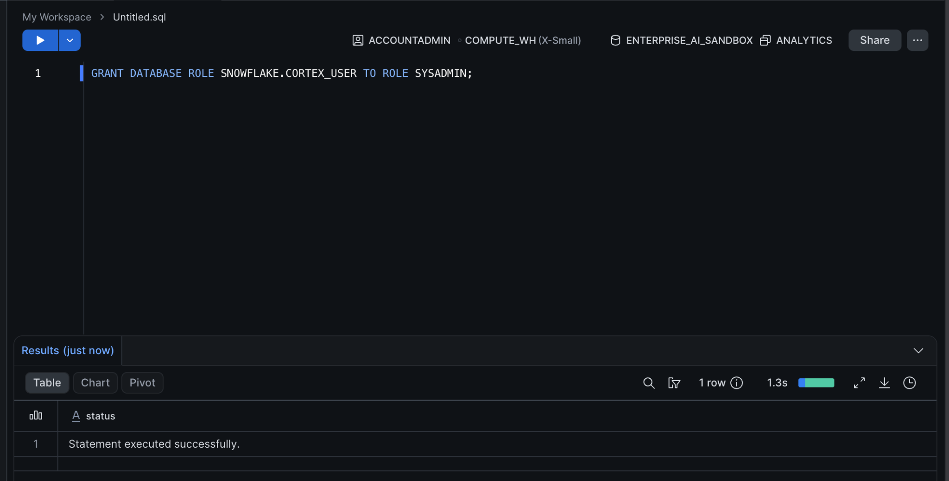

Part 2 — Seeding the Enterprise Data
We need realistic data to test our AI queries against. We will create a mock event feedback table representing standard corporate operational data.

Step 1 — Create and Populate the Table
Run the following SQL to generate the schema and insert mock records.
CREATE OR REPLACE TABLE event_feedback (
event_id VARCHAR(10),
event_name VARCHAR(100),
attendee_type VARCHAR(50),
feedback_text VARCHAR(500),
nps_score INT
);
INSERT INTO event_feedback VALUES
('EVT-101', 'TechConnect 2026', 'Executive', 'Great high-level insights, but the keynote ran 30 minutes over.', 8),
('EVT-101', 'TechConnect 2026', 'Developer', 'The hands-on labs were excellent. Food was terrible.', 9),
('EVT-102', 'Marketing Summit', 'Analyst', 'Sessions were too basic. We need deeper dives into attribution models.', 4),
('EVT-102', 'Marketing Summit', 'Executive', 'Loved the networking events. ROI was immediately apparent.', 10);

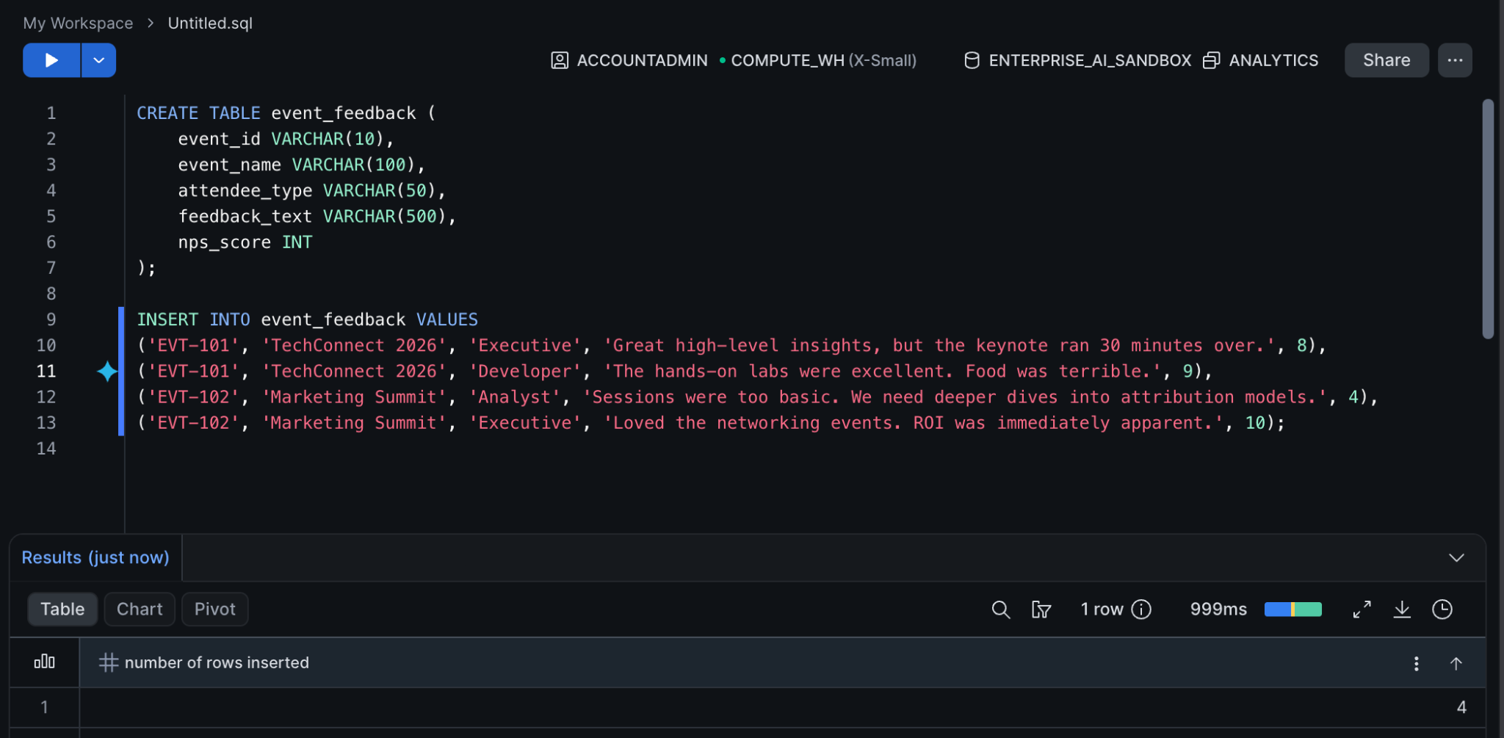

Part 3 — Extracting Insights with Cortex
Instead of building complex text-mining pipelines in Python or exporting data to external services, we will use Cortex's built-in functions to parse unstructured text instantly within our data warehouse.

Step 1 — Basic Sentiment Summarization
We will use the SNOWFLAKE.CORTEX.COMPLETE function, calling the llama3.1-8b model, to summarize the unstructured feedback column directly in our SELECT statement.
SELECT
event_name,
feedback_text,
SNOWFLAKE.CORTEX.COMPLETE(
'llama3.1-8b',
'In one short sentence, summarize the core sentiment of this feedback: ' || feedback_text
) AS ai_sentiment_summary
FROM event_feedback;
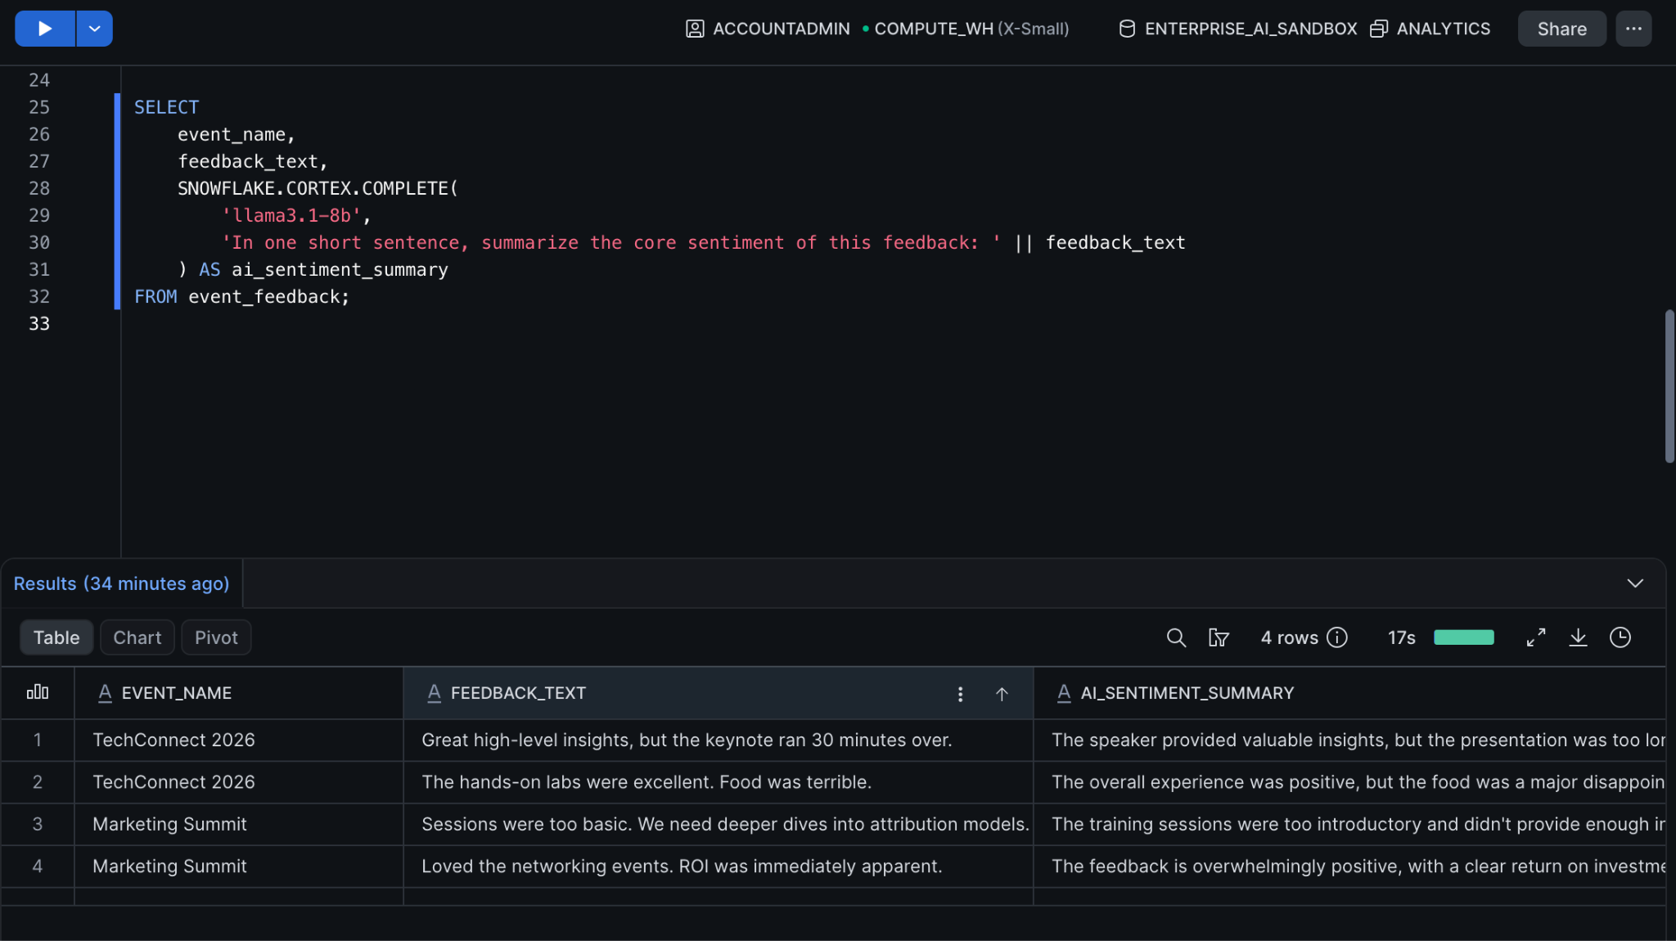
Expected Output: You should see a new column in your Snowsight results where the LLM has interpreted the raw feedback (e.g., translating "Great high-level insights, but the keynote ran 30 minutes over." into "The attendee found the insights valuable but was frustrated by the delayed schedule.").

Part 4 — Prompt Engineering for Natural Language Query (NLQ)
To let users "talk" to a dashboard, our AI agent must reliably translate human English into accurate SQL. This requires structured prompt engineering to prevent hallucination and strictly control the output format.

Step 1 — The Text-to-SQL Prompt
We must provide the LLM with the database schema context and the user's question, strictly instructing it to return only executable SQL.
SET user_question = 'How many developers attended TechConnect 2026 and what was their average NPS?';
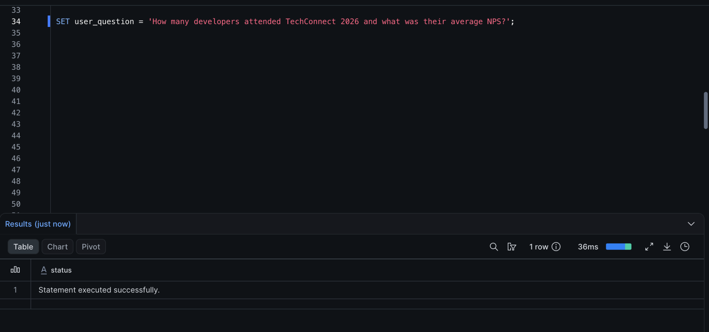
SET ddl_context = 'Table: event_feedback. Columns: event_id (VARCHAR), event_name (VARCHAR), attendee_type (VARCHAR), feedback_text (VARCHAR), nps_score (INT).';

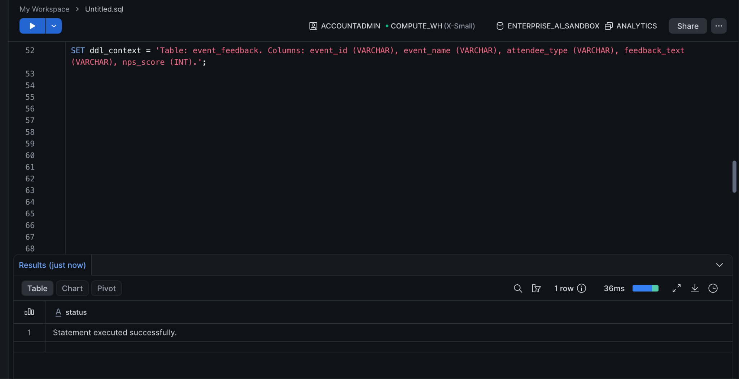
SELECT SNOWFLAKE.CORTEX.COMPLETE(
'llama3.1-8b',
'You are an expert SQL data analyst. ' ||
'Based on the following schema: ' || $ddl_context || ' ' ||
'Write a Snowflake SQL query to answer this question: ' || $user_question || ' ' ||
'CRITICAL: Return ONLY the raw SQL query. Do not include markdown formatting, backticks, or conversational explanations.'
) AS generated_sql;
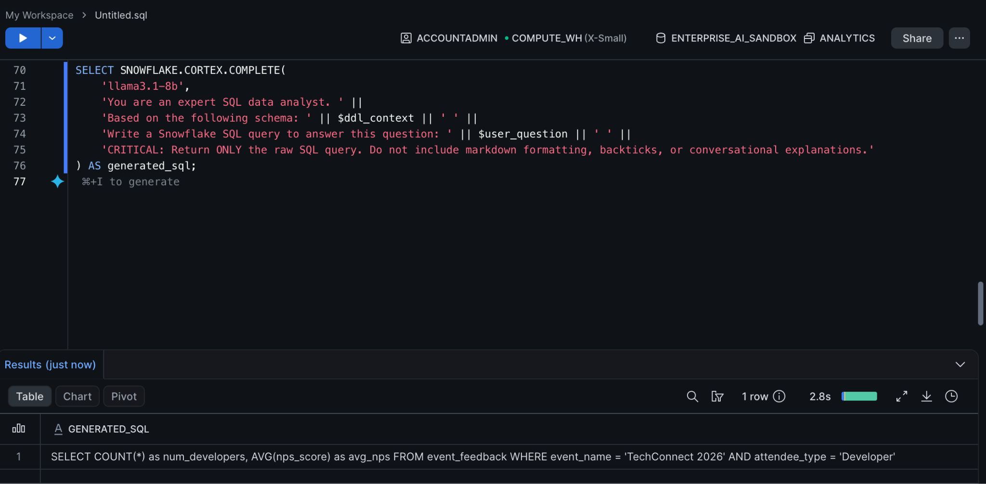
Expected Output:
SELECT COUNT(*), AVG(nps_score) FROM event_feedback WHERE event_name = 'TechConnect 2026' AND attendee_type = 'Developer';
Run the Generated Query
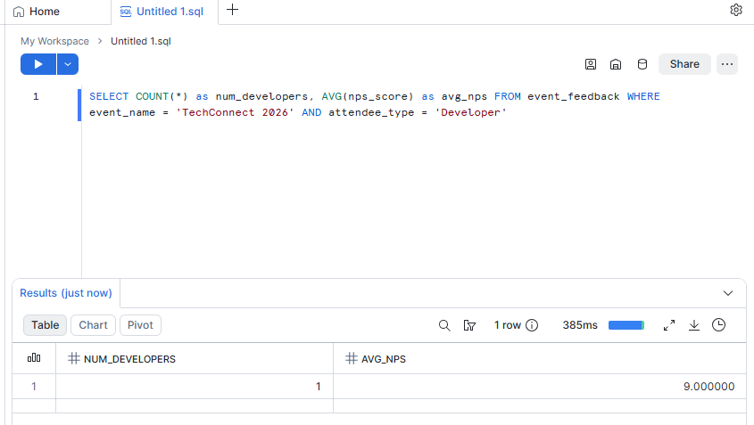

Knowledge Check
- Why is it highly advantageous for BI Engineers to use Snowflake Cortex for Text-to-SQL tasks instead of calling an external OpenAI API?
  - Answer: Security, latency, and egress costs. The data never leaves the Snowflake boundary, and the LLM inference happens in the same localized computational environment as the query execution.
- In Part 4, why did we include the explicit instruction "Return ONLY the raw SQL query"?
  - Answer: LLMs are natively conversational and will attempt to wrap code in markdown formatting or add filler text (e.g., "Here is your query:"). This breaks automation if an application attempts to execute the output string directly against the database.

Troubleshooting

Symptom: Error: "Unknown function SNOWFLAKE.CORTEX.COMPLETE" or "Insufficient privileges"
Solution: Ensure you executed the GRANT DATABASE ROLE SNOWFLAKE.CORTEX_USER TO ROLE... command in Part 1. Also verify that your Snowflake account is operating within a cloud region that natively supports Cortex features.

Symptom: The generated SQL in Part 4 includes ```sql markdown backticks.
Solution: Different LLMs interpret strictness differently. If the llama3.1-8b model still outputs markdown, adjust your prompt to be even more aggressive: Return the query as a plain string. ABSOLUTELY NO MARKDOWN, HTML, OR BACKTICKS ALLOWED.

Conclusion
In this lab, you established a secure, localized AI environment using Snowflake Cortex. You successfully proved that complex LLM inference can happen directly inside standard SQL statements, and you engineered a prompt capable of translating human language into executable database queries. This exact "Text-to-SQL" pipeline is the foundational engine that will power the custom interactive user interfaces we build in subsequent modules.

